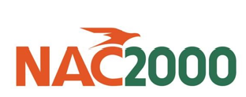**NOTICE**

Date: 7th October,2024

To: All Stakeholders

From: Customer Service Department

CC: Managing Director

**SUBJECT:** **REVISION OF TERMINAL HANDLING CHARGE (THC) AND STORAGE**

**CHARGES**

NAC2000 Corporation Limited wishes to advise its esteemed customers that with effect from Monday 14th October, 2024 Terminal handling and storage charges will be revised upwards to ensure our continued sustainability and efficiency of servicing you as our customers.

Kindly request for the revised rates on the following email address:

rates@nac2000.com.zm

customerservices@nac2000.com.zm

Kindly take this as official notification and we look forward to be of continuous service to you.

Thanking you for your usual support and cooperation.

Issued by: Customer Service